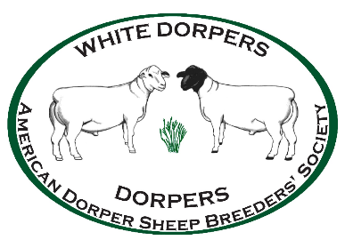
American Dorper Sheep Breeders’ Society
P.O. Box 259
Hallsville, MO 65288
Telephone: 573-696-2550
Fax: 573-696-2030
Certified Judge Ethics Agreement
This code of ethics and professional conduct applies to all judges who enter into a binding agreement to judge a show as a representative of the American Dorper Sheep Breeders’ Society. The purpose of this agreement is to establish a culture of respect and integrity in and around livestock shows where Dorper and White Dorper sheep are judged.
1. Judges will not accept any tips or money from members outside of the contracted judge’s agreement.
2. Judges will not judge any animal that has been sold off my farm for at least 90 days post sale.
3. Judges will not lodge with anyone showing in the show for which s/he is contracted with, nor will s/he associate and/or socialize prior to the show (including the evening before) or at breeder pens or trailers, until after the show is complete.
4. Judges will not accept trades or fulfill other side agreements that would knowingly elevate placings and/or sale prices.
Refusal to adhere to these guidelines can result in the forfeiture of travel, domestic and international, as well as any agreed upon stipend.

